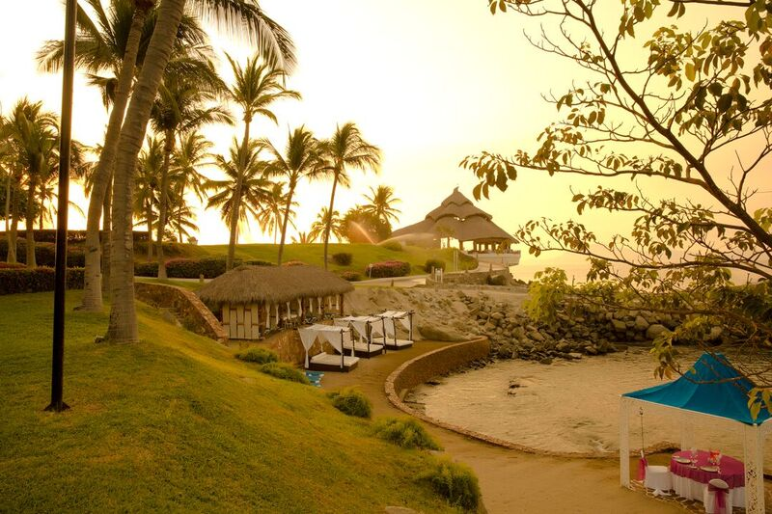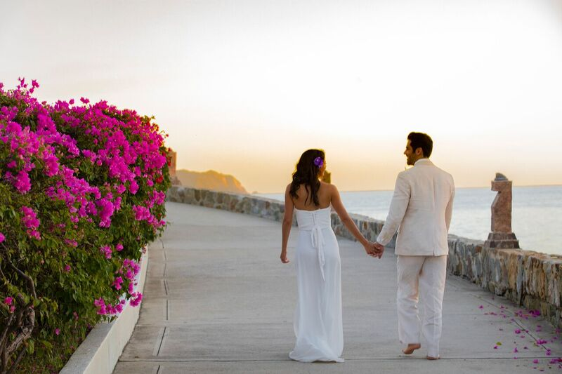

Weddings

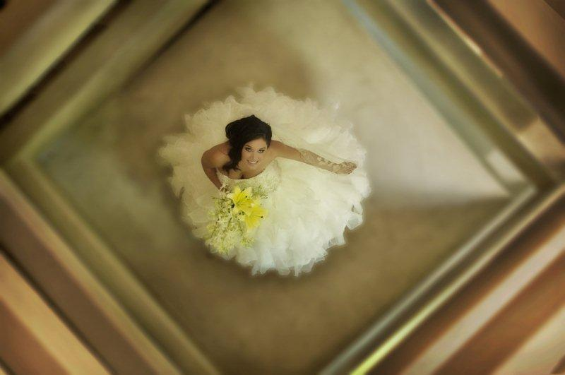

*Endless Romance*

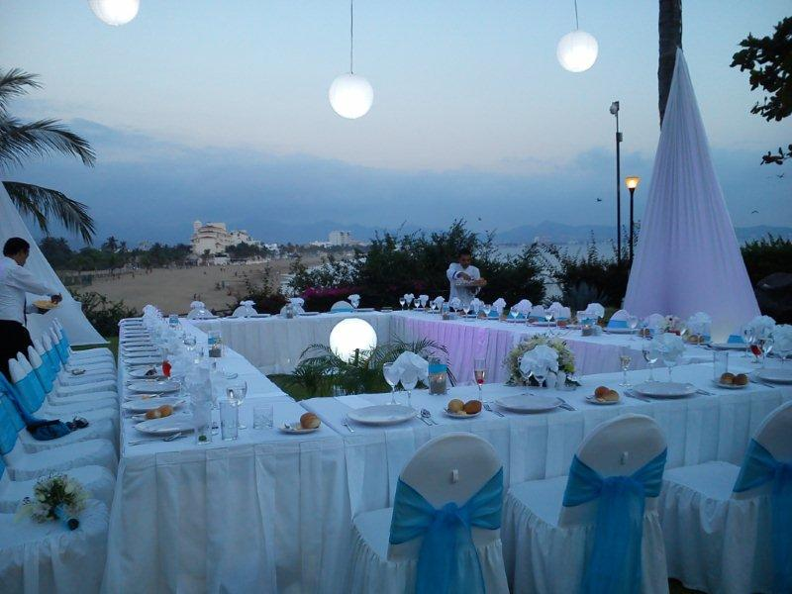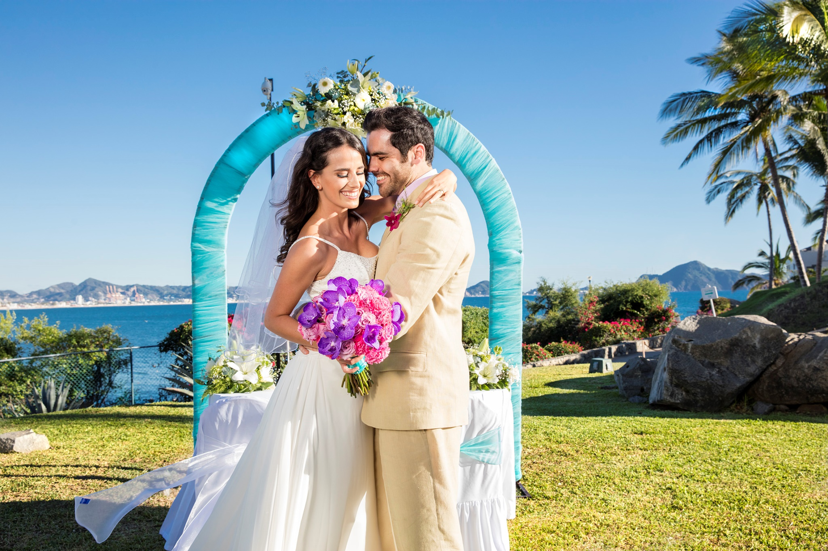

Mint

Breeze

*Endless Romance*

Wedding Package Mint Breeze

  
Wedding packages cannot be exchanged or substituted

*Price for clients staying at the Resort*

*** Guests not staying at the resort and attending the wedding must pay a Banquet services

*** Prices are subject to change without notice

Contact us at: [karmina.weddings@barcelo.com](mailto:karminapalace.weddings@barcelo.com)

* One-tiered Wedding Cake (for up 20 people)
* Two bottle of domestic champagne.
* DJ Music during the ceremony and Reception dinner
* 4 hours of private dinner with set menu in a garden with exclusive waiters.
* 4 hours open bar during reception
* Celebrate your honeymoon with champagne breakfast in bed the next morning
* Late Check out at 3:00 p.m. (on request availability) for Bride and Groom
* Bathrobes and slippers in your room
* Special decoration in the room and rose petals on the bed

**Wedding Package | $ 2,304.00 USD**

(20 people included staying at the Hotel)

* Decorated Seaside wedding location
* Upgrade to nuptial suite maximum 7 days
* Special amenities and bottle of domestic wine sent to the room
* Justice of the Peace or Minister
* Marriage certificate
* Official documents arrangements
* Bridal bouquet and groom boutonniere
* One tabletop flower arrangement
* 40 minutes Mint massage for bride and groom

*Endless Romance*

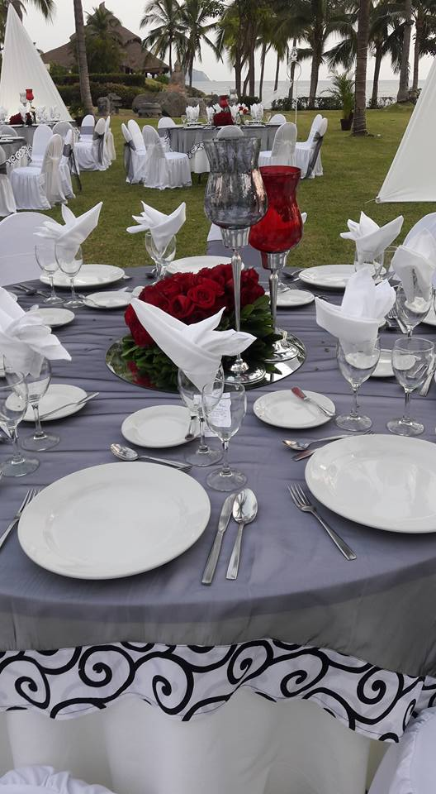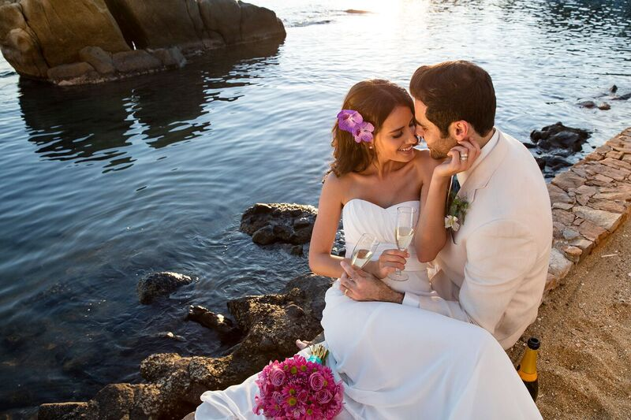

c

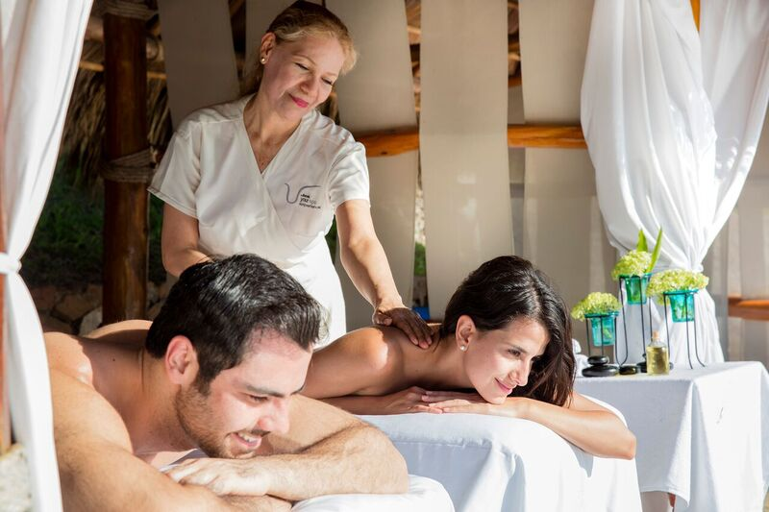

Chocolate

Sensation

*Endless Romance*

(15 people included staying at the Hotel)

* Up Grade to Master Suite with Club Premium wristband for Bride and Groom maximum 7 nights
* Decorated Seaside wedding location
* Nightly honeymoon premium amenities and bottle of sparkling wine sent to the room
* Documents arrangements
* Justice of the Peace or Minister
* Marriage certificate
* Bridal Bouquet and Groom Boutonniere
* One tabletop flower arrangement
* Arch of flowers for the ceremony
* 40 minutes Massage for Bride and Groom
* Hair style with natural white flower for the bride
* Manicure and pedicure for the bride
* Amazing body chocolate Wrap for the bride
* Deluxe Wedding Cake (for up 15 people)
* 3 bottle of domestic champagne
* DJ Music during the wedding ceremony
* 4 hours Private served dinner on the garden with exclusive waiters with set menu
* 4 hours open bar during the reception (premium drinks)
* Personalized Dessert Initial name of Bride and Groom
* Celebrate your Honeymoon with a la carte in bed breakfast the next morning
* Guaranteed late check out until 5:00 P.M.
* Romantic dinner in your Suite including a bottle of Moet Chandon
* Wedding Coordinator services
* Special decoration in the room and rose petals on the bed

Wedding Package Chocolate Sensation



Wedding packages cannot be exchanged or substituted  
*Price for clients staying at the Resort*  
*** Guests not staying at the resort and attending the wedding must pay a banquet services***  
*** Prices are subject to change without notice***

Contact us at: [karmina.weddings@barcelo.com](mailto:karminapalace.weddings@barcelo.com)

**Wedding Package | $2,919.00 USD**

*Endless Romance*

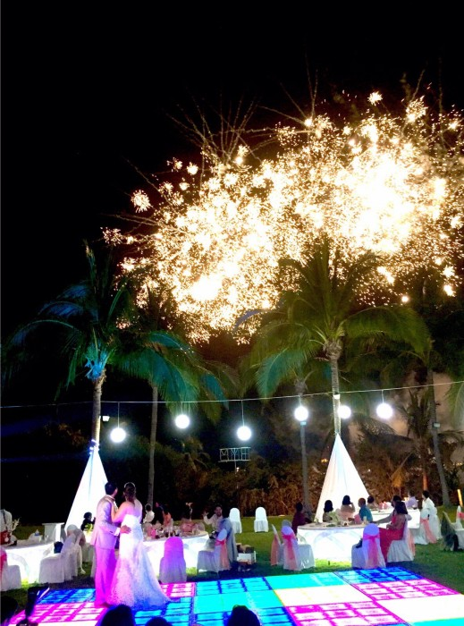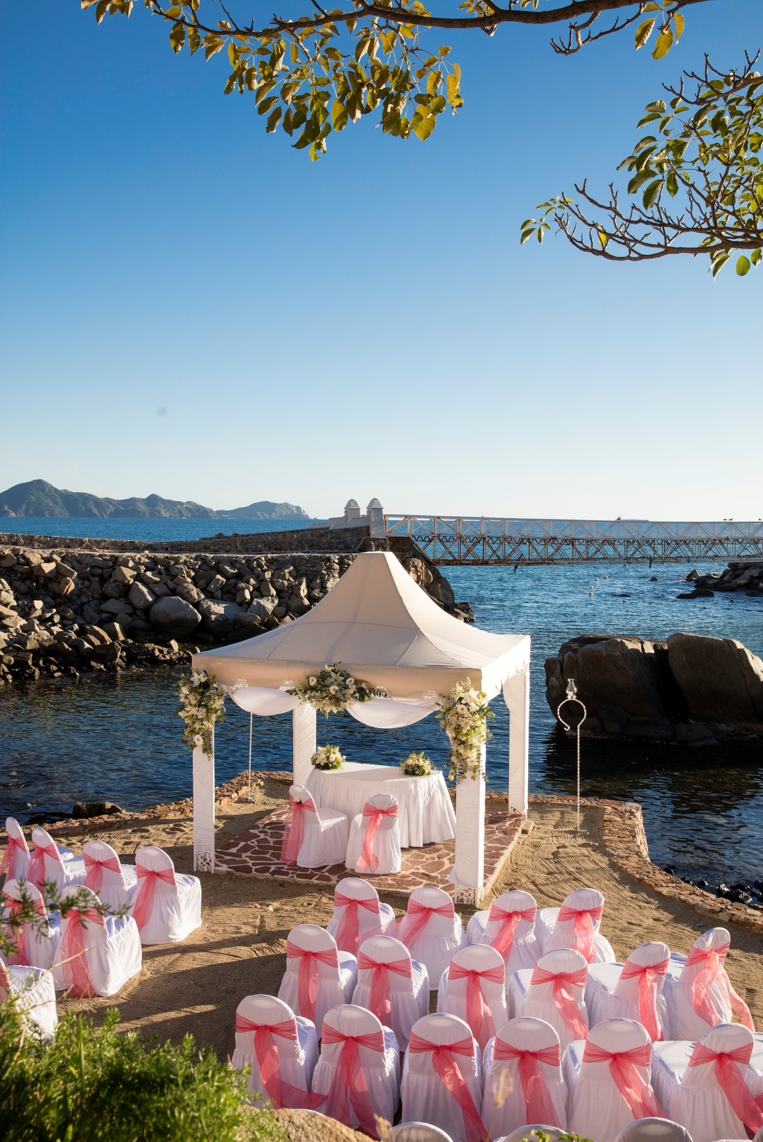

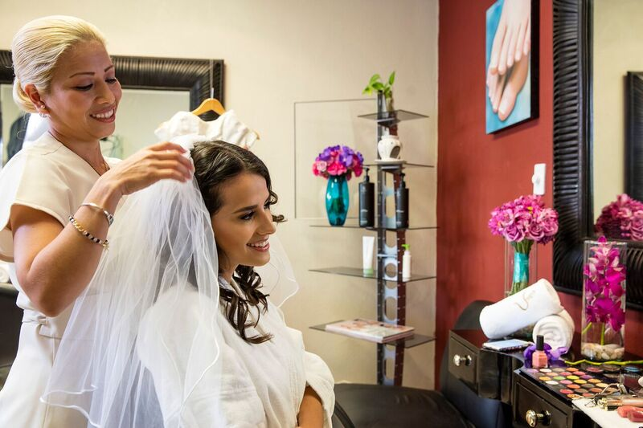

*Endless Romance*

Tangerine Sunset

Wedding Package Tangerine Sunset



Wedding packages cannot be exchanged or substituted  
*Price for clients staying at the Resort*  
*** Guests not staying at the resort and attending the wedding must pay a banquet services***   
*** Prices are subject to change without notice***

Contact us at: [karmina.weddings@barcelo.com](mailto:karminapalace.weddings@barcelo.com)

**Wedding Package | $2,935.00 USD**

(15 people included staying at the Hotel)

* Upgrade to a Suite with premium wristband for bride and groom maximum 7 nights
* Decorated Seaside wedding location
* Premium amenities and bottle of sparkling wine sent to the room
* Documents arrangements
* Justice of the Peace or Minister
* Marriage certificate
* Bridal Bouquet and Groom Boutonniere
* One tabletop flower arrangement
* Arch of flowers Arch for ceremony
* 40 minutes Romantic Massage for Bride and Groom
* Tangerine Multi-Vitamin facial
* Makeup and hair with natural white flower orchid for the bride
* Deluxe Wedding cake ( up 20 people)
* 3 Bottle of domestic champagne
* DJ music during the wedding ceremony
* 4 hours private served dinner on the gardens with exclusive waiters with set menu
* 4 hours open bar during Reception celebration
* Personalized dessert initials of bride and groom
* Celebrate your Honeymoon a la carte breakfast in the bed the next morning
* Guaranteed late check out until 5:00 P.M. for bride and groom
* Romantic candlelight dinner on the beach area or in your suite terrace
* Late Check out at 5:00 p.m. (on request availability) for Bride and Groom
* Special decoration in the room and rose petals on the bed

*Endless Romance*

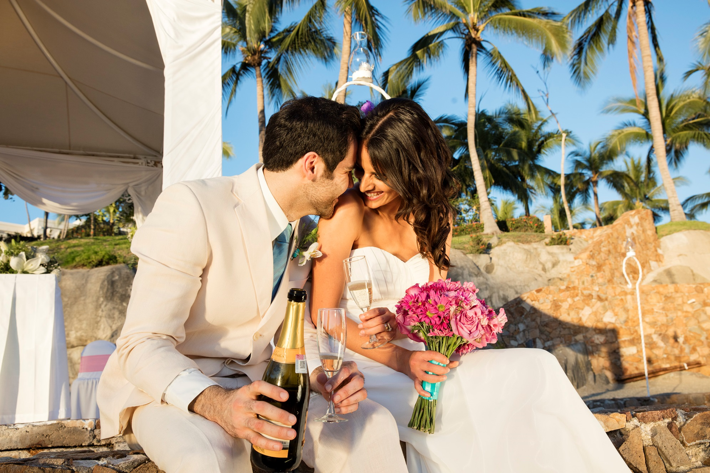

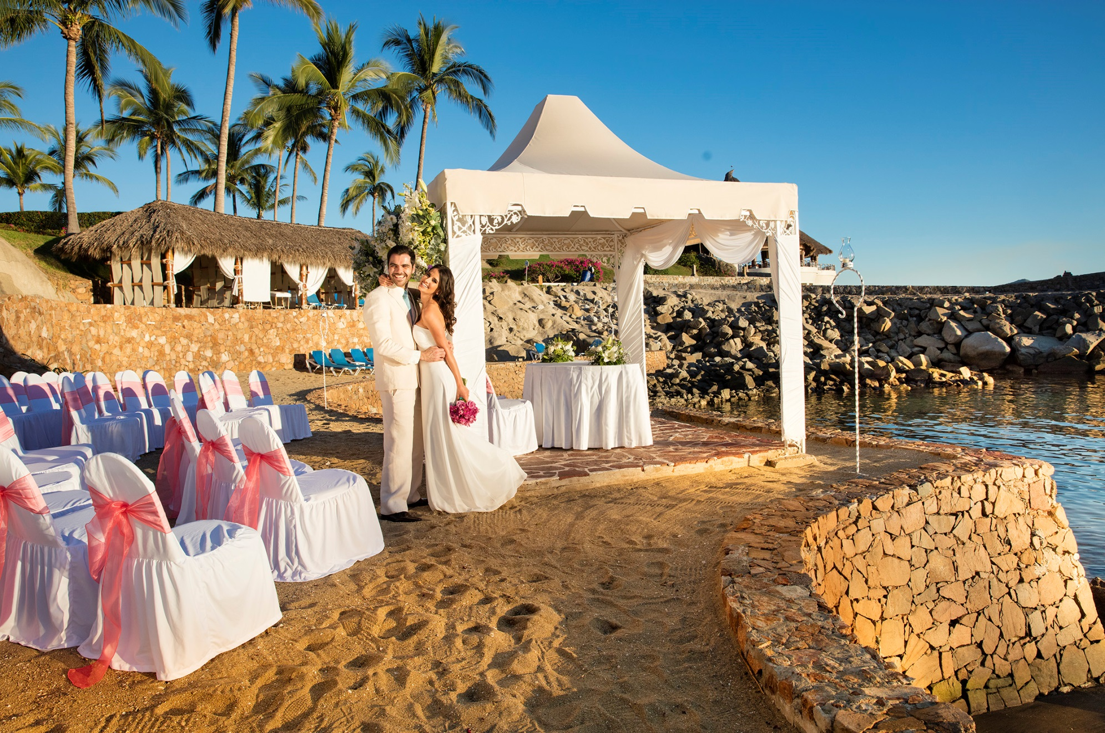

Coconut

*Endless Romance*

Wedding Package Coconut



Wedding packages cannot be exchanged or substituted

Apply for a minimum of 20 rooms for 2 nights

*Price for clients staying at the Resort*

Guests not staying at the hotel must pay full banquet for $ 65.00 USD per person plus extra for dish and drinks according to chosen menu.

*** Prices are subject to change without notice***

Not included: decoration, flowers, centerpieces, music, photographer and stylist are on their own

**Restrictions Apply.**

Contact us at: [karmina.weddings@barcelo.com](mailto:karminapalace.weddings@barcelo.com)

A minimum of 20 rooms booked for two nights is required.

* Decorated Seaside wedding location
* Wedding Coordinator services
* Witnesses if necessary
* Symbolic Wedding cake
* Domestic bottles Champagne for the toast
* Private dinner for the group with special decoration with a maximum of 3 hours, in the mounting area
* Audio system to brighten the ceremony ( recorded music )
* Breakfast in the room for the couple the day after the wedding
* Premium amenities and bottle of sparkling wine sent to the room
* King Size guaranteed
* Robes and slippers in the room
* Special decoration in the room the day of the wedding
* Double occupancy complimentary room for every 20 paid rooms per night

*Endless Romance*